Experiment #4

Function Generator, Oscilloscope

EENG 275 - W01

Prepared for: M. Fakoor, Professor

New York Institute of Technology

Prepared by: V. Cavalcante, Student

Partnered with: B. Saks, Student

New York Institute of Technology

October 25th , 2019

**Experiment Objectives**

* Familiarize with a function generator
* Familiarize with a digital oscilloscope

**Equipment Used**

1- NYIT supplied Lab Kit

1- Function Generator

1- Oscilloscope

1- 51 Ω Resistor

1- 1.5 kΩ Resistor

1- 2 kΩ Resistor

1- 5.1 kΩ Resistor

1- 0.1 µF Capacitor

1- 4.7 uH Inductor

**Results**

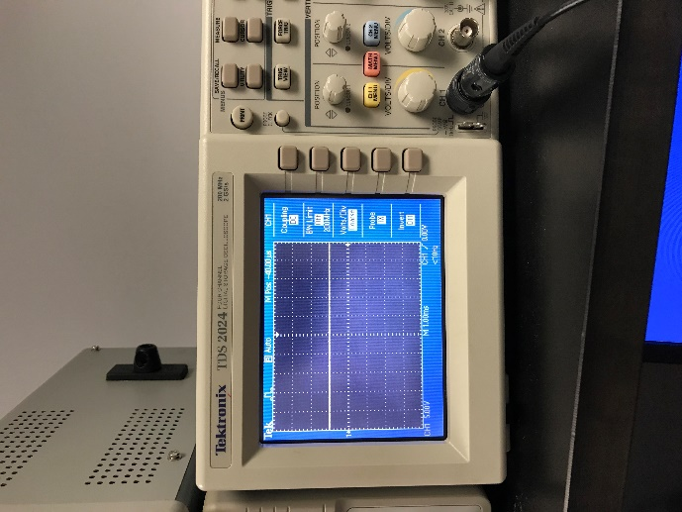 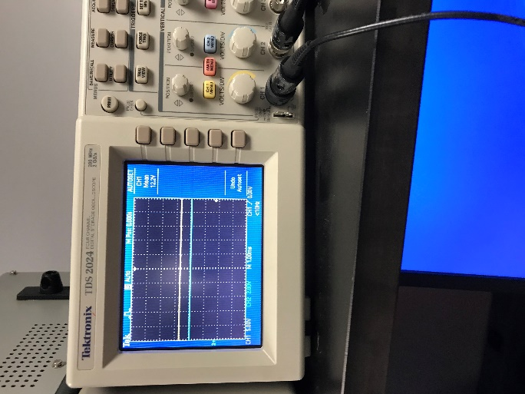

**Figure 4.11 Figure 4.12**

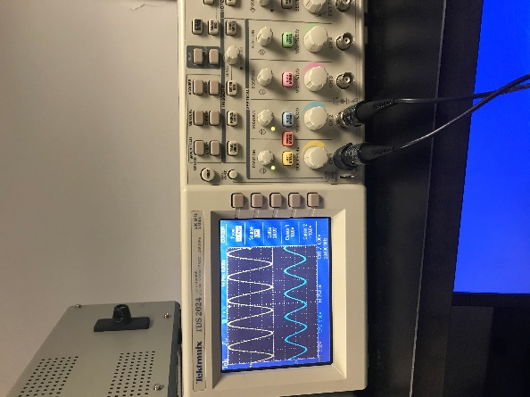

**Figure 4.15**

**Peak to Peak Voltage:**

7a) -25V

7b) -15V

7c) 10

**Measuring Frequency:**

5a) 10

5b) -10

5c) 20

6) 1/20

**Questions**

1. With these parameters it would have 5 squares for every one period.
2. It would affect the value of squares per period, thus having still 5 squares.
3. It has a DC level of 10V
4. 1 / 2.5

**Conclusion**

The change in the function generator and the DC voltage has varying effects on the amplitude and frequency of the signal in the circuit. This way you can modulate the parameters to reach a desired output.